**COLLEGE OF ENGINEERING**

Design Document

**Interleaving in Amateur Packet Radio Satellite Telemetry**

Submitted To:

Professor Dennis Silage

Senior Design Project I and II

Temple University

College of Engineering

1947 North 12th Street

Philadelphia, Pennsylvania 19122

December 2, 2013



Prepared By:

B. Keith, B. Thibodeau, and C. Destin

Faculty Advisor(s): Dr. Dennis Silage

Programmable Communication Group

Temple University

College of Engineering

1947 North 12th Street

Philadelphia, Pennsylvania 19122

For further information, please contact Dr. Dennis Silage (email: silage@temple.edu).



|  |  |  |
| --- | --- | --- |
| **Team SD1-01** | **Programmable Communication Group (PCG)** |  |
| **Team Members** | Brandon Keith, Brian Thibodeau, Cedric Destin | |
| **Advisor(s)** | Dennis Silage | |
| **Coordinator** | Thomas Sullivan | |
| **Department(s)** | Electrical and Computer Engineering | |
| **Project Title** | Interleaving in Amateur Packet Radio Satellite Telemetry | |
| **Abstract** | TBD | |
| **URL** | https://sites.google.com/a/programmable-communication-group | |

**Executive Summary**

The executive summary in your SD document should be placed just after the table of contents and other front-matter lists. In contrast to the technical and implementation summary section near the end of the document, the executive summary provides a relatively nontechnical overview of the design document, stressing aspects that support business decisions (rather than technical or implementation details). Executive readers may decide whether to support your project largely on the basis of this summary, so it needs to be self-contained and as compelling as you can honestly make it.

Unlike other sections of the design document, the executive summary for SD should just fill one *single-spaced* page. The summary must include *exactly four unnumbered paragraphs*, *without any subheads*. You can use bullets within each paragraph, however. Use literary devices as described in Markel Chapter 9 to make the summary read smoothly and coherently. Writing concisely and coherently is challenging, so allow time for multiple revisions and edits.

Table 1. Required content of four paragraphs in executive summary

|  |  |  |
| --- | --- | --- |
| Para. | Content description | Main source(s) for proposal-stage version of exec. summary |
| 1 | Summarize at a high level the challenge the project aims to meet; in many cases this will be an existing problem you wish to help solve. Aim to motivate support for your *project* — not for your specific technical approach. | *Overall Objectives* and *Historical and Economic Perspective* in **Problem Statement** section |
| 2 | Identify key design requirements and constraints, and describe in quantitative terms the technical challenges of the project. Using “quantitative terms” does not mean guessing at final numbers in the proposal stage; it means using terms that can later be quantified where appropriate. | Main discussion of **Requirements and Constraints** (for the proposed solution concept) in that section of design document |
| 3 | Briefly explain your technical design for executives, describing how it will deliver required functionality while meeting key design constraints. Don’t dwell on technical or implementation details, but do briefly describe and justify any significantly novel aspects of your approach.  *Note:* In later stages of the project, this paragraph should be revised to evaluate the design retrospectively based on extensive testing. This paragraph will then also summarize any changes still needed to make the project work. | *Proposed Solution Concept* in **Problem Statement** section.  Details of proposed design in the **Design Approach** section |
| 4 | The last part of the executive summary *realistically* touts the project’s potential for accomplishment:   * Immediate business impact if successful * Possible broader impact, if any (e.g., new uses or new markets enabled) * Social-environmental contributions, if any   Any serious reservations about these impacts should be acknowledged frankly for executive consideration. | *Implementations of Project Success* in **Problem Statement** section  [Technical] **Summary** section at end of document |

**TABLE OF CONTENTS**

1. Problem 1

2. DESIGN REQUIREMENTS 1

2.1. Functional Design Constraints 1

2.2. Non-Functional Design Constraints 3

3. APPROACH 3

3.1. DC Power Supplies 4

3.2. Hardware Design 4

3.3. Software Design 5

4. EVALUATION 5

4.1. Test Specification 5

4.2. Test Certification – Simulation 5

4.3. Test Certification – Hardware 6

4.4. Test Certification – Software 6

5. SUMMARY AND FUTURE WORK 6

6. ACKNOWLEDGEMENTS 6

7. REFERENCES 6

APPENDIX A: Product SPECIFICATION 7

APPENDIX B: SOME INTERESTING RELEVANT DERIVATION 8

# Problem

## Overall Objectives

It has been shown that channel coding yields a threefold reliability advantage over amateur packet radio satellite telemetry links that do not use channel coding (McGuire, “FX.25 On Air Performance”). This senior design project aims to demonstrate how interleaving techniques can further improve the reliability of these telemetry links. Consequently, this senior design project advocates for improved robustness in amateur packet radio communication systems, specifically in those systems dealing with satellite telemetry. Amateur packet radio satellite telemetry is often unidirectional and does not benefit from packet re-transmission via the AX.25 data link layer protocol like in most other amateur packet radio communications (McGuire, “Presentation Outline for FX.25 Proposal”). If even one bit of the AX.25 telemetry packet is received in error, the entire packet is discarded and cannot be re-transmitted (Wallio). This means that beacon signals from the amateur satellites must be transmitted with enough power to ensure that the embedded telemetry packet is received without error (Goode 1983). Error correction via channel coding and interleaving could drastically improve both network reliability and power-efficiency. This cuts the cost of satellite construction and makes amateur telemetry satellites more accessible to amateur radio operators by “reducing size, cost, and complexity of the ground antennas“ (Karn, “The BPSK1000 Telemetry Modem for ArriSSat-1”).

The ultimate goal of this senior design project is to encourage amateur packet radio satellite designers to use the FX.25 protocol, which was developed to extend AX.25 with forward error correction (FEC) capabilities. AX.25 is widely used in amateur radio satellite communications, but some amateur radio operators argue that AX.25 is not robust enough because it lacks both data compression and error correction technologies like FEC (Karn, “Toward New Link-Layer Protocols”). The FX.25 protocol currently addresses the error correction part. FX.25 has received interest by at least one design team of an amateur telemetry satellites (Neerot), but it has not gained a lot of support by the amateur radio community as a whole. One amateur radio operator thinks the FX.25 frame is too lengthy and that the protocol itself is too complicated to implement (Miller 2010), another would like FX.25 to have embedded support for several terminal node controllers and associated software (Smith 2013), and another questions whether the threefold reliability advantage over AX.25 is significant enough (Johnston 2010). As amateur radio continues to transition to software-based technologies (Lee 2012), we believe the first three concerns soon will no longer be valid. This senior design project hopes to tackle the fourth concern by exhaustively demonstrating how interleaving technologies can further improve FX.25. We believe that FX.25 can establish a robust standard for amateur packet radio satellite communications going forward.

## Historical and Economic Perspective

Provide a background overview of the problem or challenge you are researching:

* Help readers understand the significance of the problem.
* In addition to a technological history, include relevant societal, ecological, and other factors that will affect your choice of a proposed design solution.
* Explain if and how your project seeks a solution that differs from what is currently available.
* If applicable, provide a market analysis (size, revenues, price, etc.) and competitive product analysis.

**TODO: Introduce our modem and find info for typical baseband modems**

In the mid - 1900's the combined effort of the missiles and wireless communication has brought to us the technology that we now call satellites. The development done in wireless communication and controls engineering has enabled engineers to use satellites for a wide range of applications, and essentially provides an economical advantage compare to the conventional wired communication. The use of satellites has been the essence of several innovative technologies in less than 30 years, satellites have been applied for relaying digital information across the earth and also has been used for to provide information directly an individual using appropriate antennas in term of size. Those two applications of the satellites accounted for a total of 35 billion dollars in 2000 [1], and is a number that is still increasing due to the numerous applications of digital communications.

Amateur Radio operators have also slowly followed the trend of satellites for communication purposes. Although their vantage point in terms of bandwidth and also orbits, Amateur Radio operators have used Low-Earth Orbiting satellites ( Find altitude) to develop several applications which consist of the Slow-Scan Television, Automatic Packet Reporting System for weather reports and telemetry and several others organized by Radio Amateur Satellite Corporation (AMSAT.) The communication between the satellite and the earth stations is established through the modulation of a carrier signal with the desired digital data, several modulation schemes have researched, the dominant ones are the Amplitude modulation, Frequency modulation and finally the Phase modulation, where in each of the those modulation the amplitude A, frequency f and phase \theta of equation # are modulated to represent the digital information. The phase modulation technic is the most effective modulation scheme for establishing a communication with spatial vehicles such as satellites, a very popular usage of the phase modulation is for Global Positioning Systems (GPS) which through the use of a complicated Phase Shift Keying method, the positions are obtained for by stationary or moving receivers.

**This is where you need to talk about the baseband modems**

**Try to see what they do for GPS**

**Talk about the advantages of BPSK over others**

**Look at old models implementation in analog that would be John’s design**

With the benefits of BPSK modulations, amateur radio operators have taken the advantage of BPSK’s robustness against the effects of Doppler shift. Since BPSK has been a fairly new modulation scheme, in contrast to amplitude and frequency modulation, most amateur radio operators did not own the hardware compliable for the communication. One of the designs that has allowed the implementation of BPSK communication in early 90’s is described by John Magliacane who in 1993 implemented a 1200bit/s modem for PACSAT communication [3]. The modem was a breakthrough design for amateur radio operators which has encouraged radio operators, including the PGC to implement modern satellite communication using BPSK modulation scheme.

Regarding the cost of owning an active amateur satellite station is assumed to be an expensive but on the other hand, it could be affordable to be equipped with a station. A current operator Steve Primer has published the adequacy of having a radio satellite station and listed the cost of setting such station to range between $150-3000, where the cost would include Yagi antennas, an azimuth and elevator rotator (AZ\EL Rotator) which is an essential equipment to follow the position of the satellite, a VHF/UHF transceiver, and finally a receiver amplifier and pre-amplifier [2].

With the commitment of several operators, amateur radio satellites have played a very important role to the community during natural disasters. In the events of disasters similar to Katrina in Louisiana and Sandy in East Coast, amateur radio operators have benevolently used their station to communicate distress messages.

## Candidate Solutions

Explore potential solutions in an open-minded way, so as not to prematurely settle on a possibly inferior solution:

* List possible technical and nontechnical solutions to the overall problem.
* Briefly mention and dismiss any apparent solutions that are clearly not feasible, to show that you considered them (and to enable your reviewers to challenge your dismissal of them).
* Methodically discuss the pros and cons of the remaining candidate solutions along with any tradeoffs or other relationships between them.

The LEO-AMSAT’s that we are interested in communicating with are also known as packet satellites (PACSAT). This is because they use the AX.25 protocol which transmits packets of data. Packets are also known as frames and each frame consists of several fields. These fields include flag, control, and address information in addition to the data to be sent. Since TNC’s are responsible for AX.25 encoding and already contain a modem within, we originally considered an FPGA implementation of a TNC. However, the complexity and depth of the AX.25 protocol in addition to a modem design was determined to be too ambitious given the time constraint of two semesters. Instead, we simply chose to design an FPGA modem that would interface with the TNC and transceiver.

### Modulator

The design of any modem requires two fundamental components, a modulator and demodulator. The modulator is responsible for taking baseband data and either source encoding it, or translating it passband levels necessary for radio transmission. There are many source encoding schemes that have been developed in the course of digital communication. Each of them has their own benefits as far as bandwidth requirements or self-clocking characteristics. Listed below are a few of the more common schemes encountered in communication systems:

1. Return to Zero (RZ)
2. Non-Return to Zero (NRZ)
3. Non-Return to Zero-Inverted (NRZI)
4. Bi-phase Manchester

Our modem was designed to interface between the TNC and the transceiver. This means our modem will only perform baseband modulation. From the TNC, the modem receives AX.25 data streams and further processes them using a bi-phase Manchester encoder. The benefit of bi-phase Manchester code is that it is self-clocking which makes timing synchronization easier on the receiving end.

### Demodulator

The demodulator is responsible for providing either coherent or non-coherent demodulation. Coherent demodulators require phase synchronization between the received signal and the locally generated oscillator. Conversely, Non-coherent demodulation does not require synchronization and makes no attempt to estimate the phase of the received signal. The advantage of non-coherent modulation is that it does not require additional hardware like phase-locked loops which are used to lock onto the incoming carrier phase. However, the LEO-AMSAT’s we are interested in communicating with use BPSK for downlink and thus requires the design of a coherent demodulator.

The successful extraction of information from a received signal in a coherent demodulator requires both carrier and timing synchronization. Figure 1 illustrates the architecture of a typical coherent demodulator.

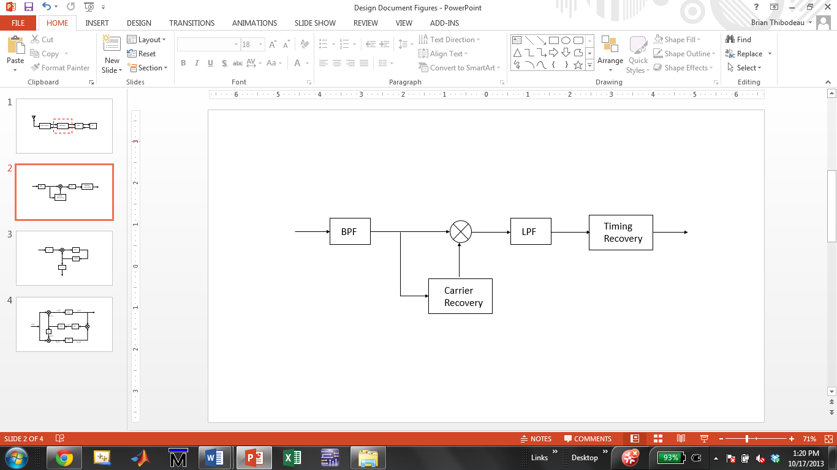

Figure 1. Received waveform takes two paths. First path extracts carrier for coherent demodulation and the second path recovers timing information. This architecture is based on the optimum binary receiver

The received signal from the transceiver is first processed by a band pass filter to remove as much noise as possible and then sent to the carrier recovery circuit. Recovering the carrier is done in one of two ways, the squaring loop or the Costas loop. Each method utilizes phase-lock concepts and has its own advantages and disadvantages in terms of complexity and performance.

### Carrier Recovery using Squaring Loop

The squaring loop is a popular choice for coherent demodulation of BPSK waveforms. It’s mathematically easy to analyze and its hardware implementation is not as complex as the Costas loop. As the name implies, the received signal is squared to remove any phase offsets and then processed by a bandpass filter to remove as much noise as possible. After the band pass filter, the signal is fed to a phase-lock loop (PLL) for phase and frequency tracking. Once the output of the voltage controlled oscillator (VCO) is locked in phase and frequency with the received signal, its frequency is divided by two. The resulting carrier is fed back to the mixer where it is mixed with the received waveform and the timing can be recovered. The operation of the squaring is shown in Figure 2.

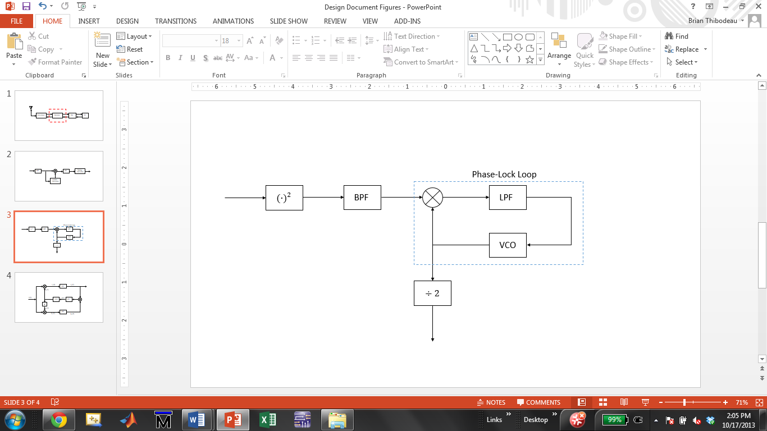

Figure 2. Squaring loop used for carrier recovery in the coherent demodulator. The Phase-Lock Loop utilizes feedback to track and lock onto in the received waveforms suppressed carrier

### Carrier Recovery using Costas Loop

Another method for carrier recovery was proposed by John P. Costas in his 1957 paper, *Synchronous Communication*. Unlike the squaring loop whose only purpose is suppressed carrier reconstruction, the Costas loop is capable of synchronous data detection in addition to suppressed carrier reconstruction. One of its disadvantages is its mathematical complexity compared to the squaring loop, but in terms of hardware components needed for complete coherent demodulation, they both require approximately the same amount.

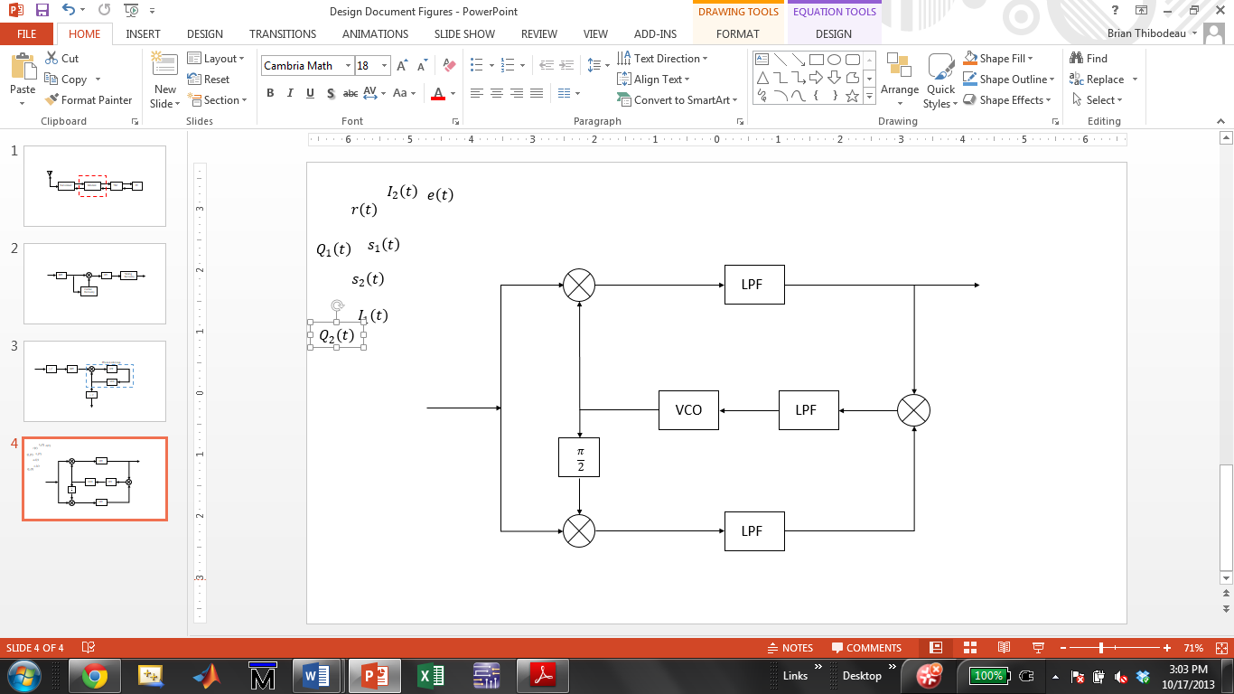

Figure 3. Costas loop used for suppressed carrier reconstruction as well as synchronous data detection.

Coherent modulation utilizing the Costas loop would require one band-pass filter, three low-pass filters, three multipliers and a VCO. Likewise, the squaring loop would also require one band-pass filter, three multipliers (including the squarer) and a VCO. Instead of three low-pass filters needed by the Costas, the squaring loop only requires two. Note also that the squaring loop requires a flip-flop for frequency division, but with today’s FPGA’s, a single flip-flop is negligible. The decision for implementing the squaring loop versus the Costas loop will ultimately be decided by their tracking and locking performance in the presence of noise and Doppler shifts (See section 1.5, Major Design and Implementation Challenges).

### Timing Recovery

## Proposed Solution Concept

Based on the preceding subsection:

* Propose a particular solution (or complementary combination of solutions) that you want your project to pursue.
* Justify your choice by explaining how the previously discussed pros and cons make your solution concept preferable to other alternatives.

In order to provide Temple University’s radio club with a robust and reliable modem, it must be able to be interfaced with a transceiver and the TNC. This requires a single analog to digital converter for received signals and a single digital to analog converter for transmitted signals. Figure 4. Illustrates the how the 1200pbs modem fits into the system level model

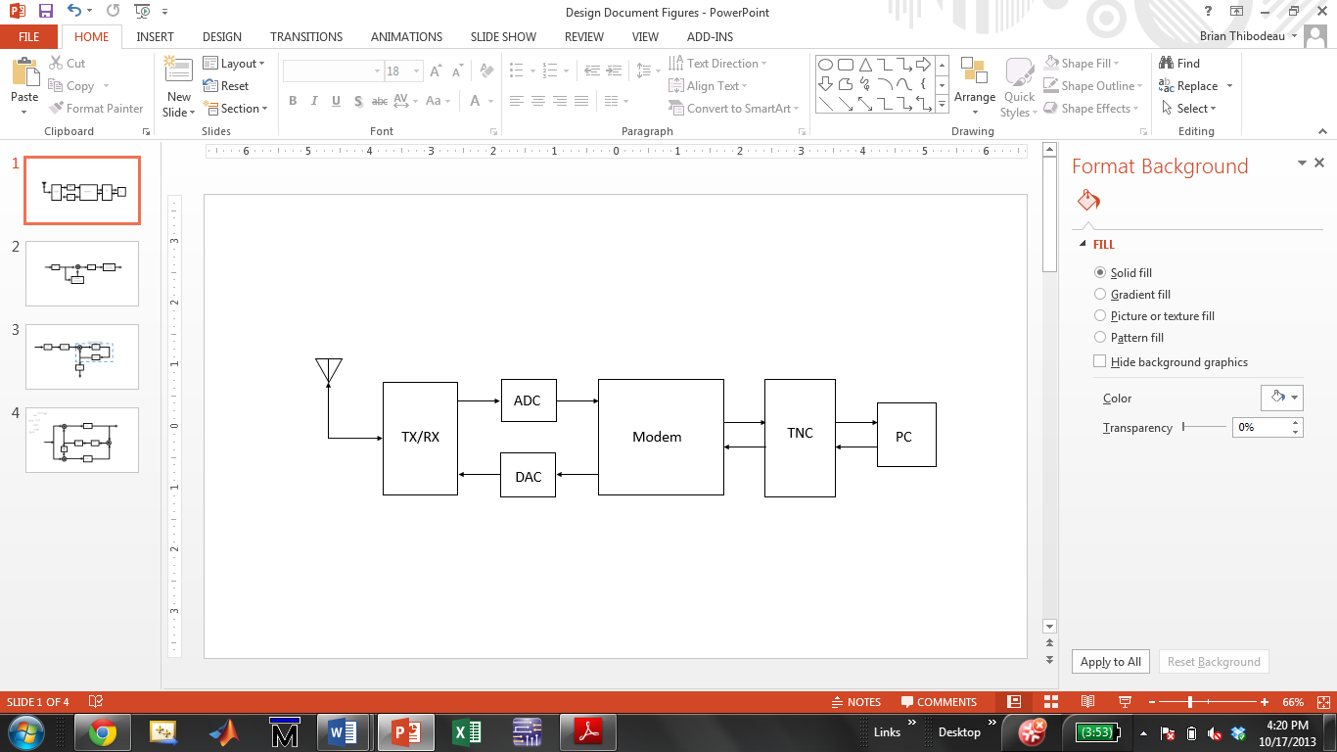

Figure 4. System level diagram showing how the 1200bps modem interfaces with the transceiver and TNC.

The Xilinx Spartan-6 LX-9 Microboard was selected for our modem implementation because of its good performance and low cost. It also provides the two Pmod expansion ports needed for interfacing Digilent’s 12-bit AD1 ADC and 12-bit DA2 DAC.

It was determined through simulation that optimum coherent demodulation was achieved from the use of a (squaring or Costas) loop. The result is a modem design that incorporates a bi-phase Manchester encoder for baseband modulation of AX.25 data streams, and a (squaring or Costas) loop for coherent demodulation of BPSK signals.

## Major Design and Implementation Challenges

Concisely describe the main hurdles to be overcome in designing and implementing your proposed solution concept:

* First do so in nontechnical terms.
* Then provide a more specific technical formulation of the major challenges.

Include only challenges that any team would have to overcome. Challenges due to your team’s lack of knowledge or experience, outside commitments, interpersonal issues, or other difficulties would be addressed to your manager in a separate memo.

The biggest design challenge associated with this project is the development of a carrier reconstruction circuit that is capable of mitigating the effects of Doppler shift. The relative motion of satellites in orbit around earth with respect to the ground station can cause the received frequency to appear 20 kHz above or below its nominal downlink frequency. In John A. Maglicane’s 1993 design, he derived a control signal from the carrier recovery circuit that simulated a person tuning the transceivers frequency control button. In our design, Doppler shift correction will be done autonomously through the use of a type II PLL.

The challenge is designing a stable control loop that minimizes time to lock and inter-symbol interference but still has a narrow enough bandwidth to reduce noise and the bit error rate. Since the PLL is an inherently non-linear system, it must be linearized in terms of the phase of the received signal. This problem becomes more challenging if the Costas loop is implemented because the arm filters much be matched perfectly. However, the advantage of an all digital Costas loop is that designing two identical filters is much easier than if it were done with analog components.

## Implications of Project Success

Describe what may realistically be expected to happen if your project is successful. Style this prediction as a businesslike projection, not a world-changing manifesto. Give thoughtful attention to the following aspects of this prediction:

* Implications of the product or method itself
* Business implications for your organization in particular
* Implications, if any, to the overall market
* Environmental and related issues, if any
* Social justice and related issues, if any

In this section, you will define the problem you are addressing, explain its significance, and discuss the impact of your solution (not how you are going to solve the problem, but what will happen if you solve the problem). Start with a general overview, background, etc., and then get progressively more detailed. This section must be at least two pages long.

The successful design of a 1200bps modem will enable Temple University Amateur Radio club to communicate with LEO-AMSATs that use FSK for uplink and BPSK for downlink. Although software is available that will perform the modem functions, an FPGA modem demonstrates the potential for high speed processing in integrated circuits.

# DESIGN REQUIREMENTS

Start with an introductory paragraph or two. Then you will list your specific design constraints, followed by an explanation. This section should be at least three pages long.

Design constraints must be quantitative and must be testable. The section on evaluation will describe the tests you use to verify your design constraints.

## Functional Design Constraints

Our five functional design constraints are shown in Table 2. Each team must have five functional design constraints that adequately constrain the design of the physical system (including software). Functional design constraints typically relate to the performance of the system. Note the format of the table and the use of a cross-reference in the text above.

You will need several paragraphs explaining these design constraints. Typically these are explained in groups since design constraints are often interrelated. Use constraints that relate to well-known standards (such as UL or FCC specs), and be sure to explain these specifications.

|  |  |
| --- | --- |
| **Name** | **Description** |
| Signal to Noise Ratio | We will achieve a signal-to-noise ratio of 30 dB or greater, and demonstrate that this exceeds performance of existing technology. |
| Communications Protocol | We will use an RS-232C interface for communications between the module and the base station. |
| Accuracy | This system’s incorrect classification rate will not exceed 3.5% on data whose SNR exceeds 15 dB. |
| Robustness | The imposter acceptance rate will not exceed 3% on data whose SNR exceeds 10 dB. |
| Transmission Distance | Our base station will communicate with the server at a maximum distance of 100 feet with a bit error rate not to exceed 1e-05. |

Table 2. Functional design constraints for the GADGET system.

## Non-Functional Design Constraints

In the ABET handbook on accrediting engineering programs, it states:

“Students must be prepared for engineering practice through the curriculum culminating in a major design experience based on the knowledge and skills acquired in earlier course work and incorporating engineering standards and realistic constraints that include most of the following considerations: economic; environmental; sustainability; manufacturability; ethical; health and safety; social; and political.”

|  |  |  |
| --- | --- | --- |
| **Type** | **Name** | **Description** |
| Economic | Cost | The expected retail for this price is $100 based on a parts cost of $25. |
| Environmental | Power | The main processor unit will dissipate no more than 3 Watts. |
| Sustainability | Reliability | This system will be designed to operate over a five year period without failure. The expected battery life is seven years and is the only part requiring regular maintenance. |
| Manufacturability | Size | The physical dimensions will be 3” high, 4” wide, and 6” deep. |
| Health and Safety | Safety | We will conform to UL Specification 631 which requires that this unit not deliver an electrical shock to the user under …, and UL Specification 837 which requires a …. |

Table 3. Non-functional design constraints for the GADGET system.

Every senior design project must include five design constraints that address some of these issues. See the lecture notes for some ideas on the types of non-functional design constraints that you can use. An example of these are shown in Table 3. These typically include things like size, power, weight, and cost. Every project need not address all of the factors specified by ABET. However, all projects must have five design constraints that relate to these issues.

After you provide these constraints, some explanation will be required.

# APPROACH

In this section, you explain your approach in great detail. This will be the single largest section in the document, often 20 or 30 pages long. It will contain a comprehensive explanation of your design, including theory and practice. It should be somewhat self-contained so that a student with a background similar to yours can understand it. It will most likely use two levels of subsections (e.g., 3.1 and 3.1.1). Only the first level of subsections (e.g., 3.1) needs to be included in the Table of Contents.

Figures should appear as shown below and be referenced in the text as Figure 1. Similarly, tables should be included in the text and be referenced as Table 1 (see the examples in the previous section). All text in figures and tables, including the captions, use a 9 pt. Times New Roman font (as does the text).

Equations in your document should appear as shown below with the equation number in parentheses to the right of the equation. Use a medium-sized font — one that matches the rest of the document:

We will follow APA format for citations. See REFERENCES for more information on the format. References are cited in the text using an in-line style. For example, the best way of developing a DC power supply is to use a Duracell battery (Anderson, 2005). Many approaches exist for developing such things, but my favorite one is an approach which is really space efficient (Anderson, *et al.*, 2003). Note that APA style does not require the use of cross-references (Armony & Dolan, 2002).

## DC Power Supplies

You should probably start this section with a general overview of the primary technology you are developing. Then you can transition into the specifics of the hardware and software design.

[Some filler text here … Some filler text here … Some filler text here … Some filler text here … Some filler text here … Some filler text here … Some filler text here … Some filler text here … Some filler text here … Some filler text here … Some filler text here … Some filler text here … Some filler text here …]

[Some filler text here … Some filler text here … Some filler text here … Some filler text here … Some filler text here … Some filler text here … Some filler text here … Some filler text here … Some filler text here … Some filler text here … Some filler text here … Some filler text here … Some filler text here …]

[Some filler text here … Some filler text here … Some filler text here … Some filler text here … Some filler text here … Some filler text here … Some filler text here … Some filler text here … Some filler text here … Some filler text here … Some filler text here … Some filler text here … Some filler text here …]

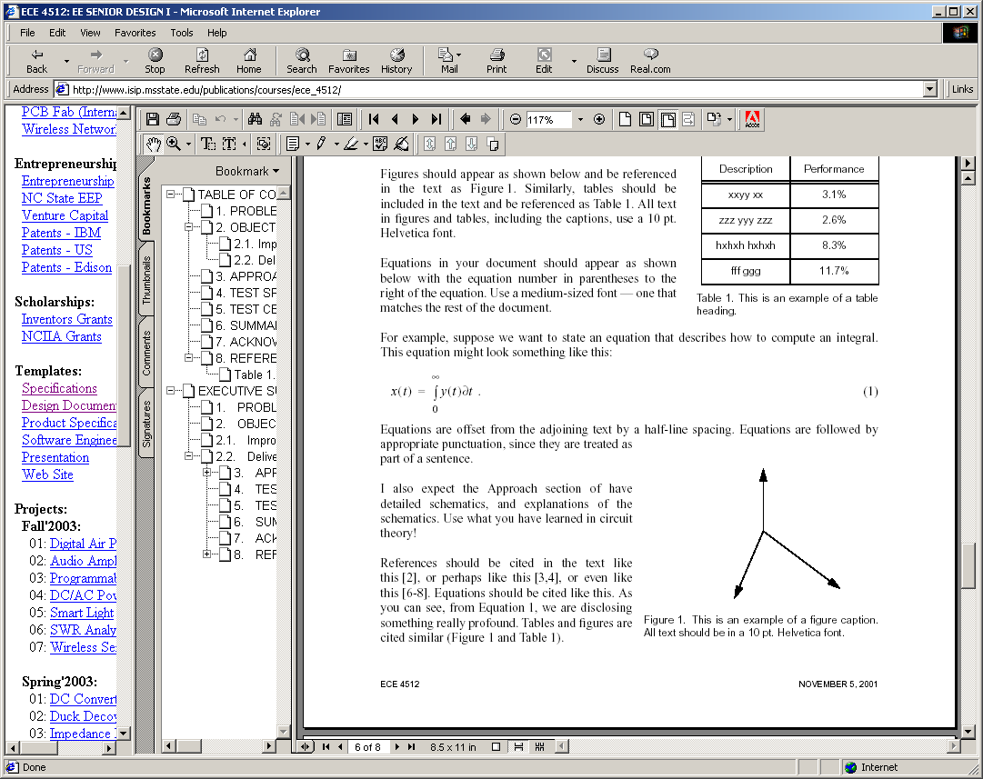

Figure 1. This is an example of a figure. Captions are justified when they are multiple lines, and centered if they are one line. Captions should be no more than about three lines.

For example, below, in Figure 1, we can see some interesting experimental results. This results are supported by the all important equation of life:

 (1)

We can see in Equation (1) that the mystery of life is explained.

## Hardware Design

Each project will describe their hardware and software designs in major sections. Hardware design should begin by developing a block diagram of the overall system, and then expanding on the theory and design behind each one of these blocks.

Some interesting text goes here… Some interesting text goes here… Some interesting text goes here… Some interesting text goes here… Some interesting text goes here… Some interesting text goes here… Some interesting text goes here… Some interesting text goes here… Some interesting text goes here… Some interesting text goes here… Some interesting text goes here… Some interesting text goes here… Some interesting text goes here… Some interesting text goes here… Some interesting text goes here… Some interesting text goes here… Some interesting text goes here… Some interesting text goes here… Some interesting text goes here… Some interesting text goes here…

### Theory of DC Power Supplies

Some interesting text goes here… Some interesting text goes here… Some interesting text goes here… Some interesting text goes here… Some interesting text goes here… Some interesting text goes here… Some interesting text goes here… Some interesting text goes here… Some interesting text goes here… Some interesting text goes here… Some interesting text goes here… Some interesting text goes here… Some interesting text goes here… Some interesting text goes here… Some interesting text goes here… Some interesting text goes here… Some interesting text goes here… Some interesting text goes here… Some interesting text goes here… Some interesting text goes here…

### More Interesting Theory

Some interesting text goes here… Some interesting text goes here… Some interesting text goes here… Some interesting text goes here… Some interesting text goes here… Some interesting text goes here… Some interesting text goes here… Some interesting text goes here… Some interesting text goes here… Some interesting text goes here… Some interesting text goes here… Some interesting text goes here… Some interesting text goes here… Some interesting text goes here… Some interesting text goes here… Some interesting text goes here… Some interesting text goes here… Some interesting text goes here… Some interesting text goes here… Some interesting text goes here…

## Software Design

We will go through a formal software design process in class. You can use most of this material for your software design. More details will be given on this during classroom lectures.

Some interesting text goes here… Some interesting text goes here… Some interesting text goes here… Some interesting text goes here… Some interesting text goes here… Some interesting text goes here… Some interesting text goes here… Some interesting text goes here… Some interesting text goes here… Some interesting text goes here… Some interesting text goes here… Some interesting text goes here… Some interesting text goes here… Some interesting text goes here… Some interesting text goes here… Some interesting text goes here… Some interesting text goes here… Some interesting text goes here… Some interesting text goes here… Some interesting text goes here…

# EVALUATION

This section contains two major sections.

## Test Specification

Describe in detail what tests you will run to verify your design constraints. I expect three subsections for simulation, hardware, and software.

## Test Certification – Simulation

Describe how you used simulations to verify your design.

## Test Certification – Hardware

I expect two subsections here: one for the prototype and one for the packaged version.

## Test Certification – Software

Again, two subsections for the prototype and packaged system.

# SUMMARY AND FUTURE WORK

This section will be about one page long and review what was accomplished (what worked? what didn’t work?), and talk about future extensions of the project (what things could be done better? what things needed to be done differently to overcome problems).

# ACKNOWLEDGEMENTS

We wish to acknowledge John Doe of ABC Corporation, Dr. John Smith of the National Institute

for Cool Things, and Dr. I.M. Smart of XYZ for their continued support and feedback regarding this project. We also acknowledge the National Science Foundation for its funding of this project, which enables many useful on-line documents to be developed. Mr. Doe’s interactions have helped us add features to the system, some of which make this system very unique compared to other systems. Say a few more good things.

# REFERENCES

Anderson, A. K. (2005). Affective influences on the attentional dynamics supporting awareness. *Journal of Experimental Psychology: General*, *154*, 258–281.

Anderson, A. K., Christoff, K., Panitz, D., De Rosa, E., & Gabrieli, J. D. E. (2003). Neural correlates of the automatic processing of threat facial signals. *Journal of Neuroscience*, *23*, 5627–5633.

Armony, J. L., & Dolan, R. J. (2002). Modulation of spatial attention by fear-conditioned stimuli: An event-related fMRI study. *Neuropsychologia*, *40*, 817–826.

References must follow APA format. There are many good sites that describe these standards. Here are two that I find very useful:

<http://en.wikipedia.org/wiki/APA_style>

<http://flash1r.apa.org/apastyle/basics/index.htm>

Your overall reference list should be close to 50 items, with at least 25 of these coming from peer-reviewed journals and books.

1. Product SPECIFICATION

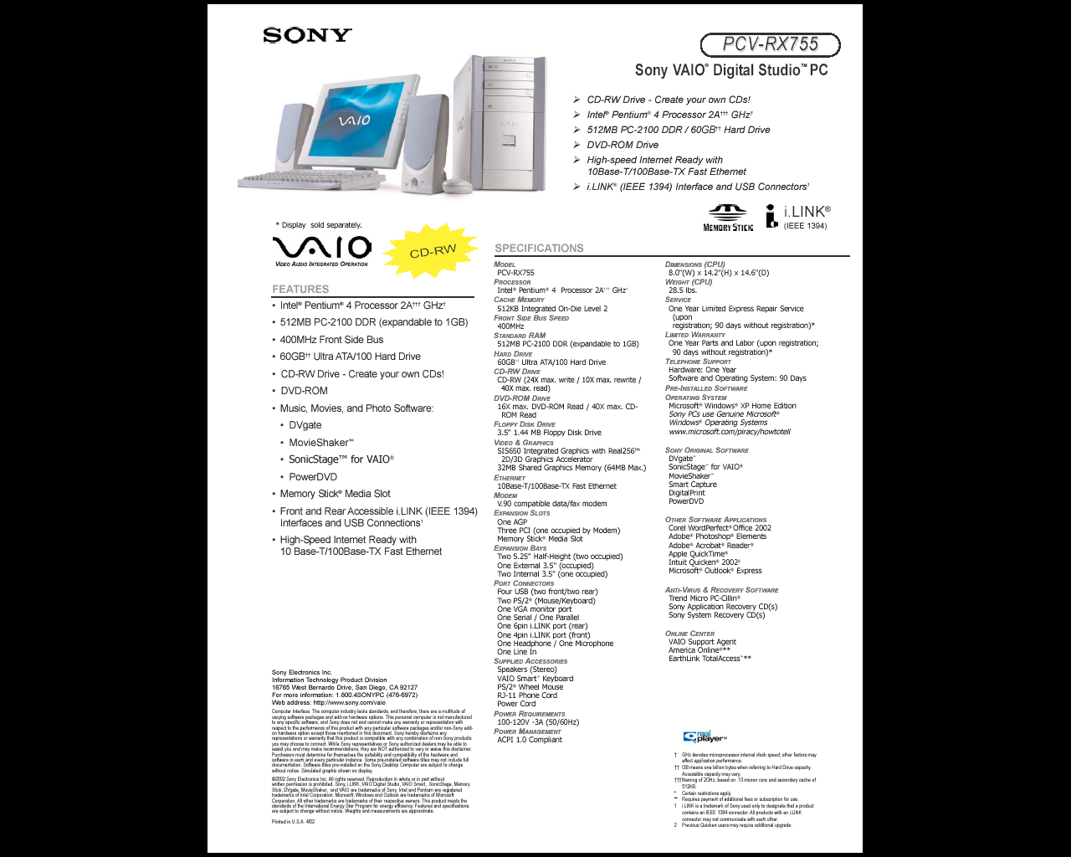

1. SOME INTERESTING RELEVANT DERIVATION

Software listings are generally NOT included in the document. These should be on the web site and referenced from the document using a URL.

It is common, however, to want to discuss a specific point or derive an important relationship. Such details, when not immediately relevant to the document, are best included as appendices.